

…..Nourishing Mind, Body and Soul

**PURA VIDA RETREAT & SPA**

**Costa Rica 2025/26.**

*Here is some general information which you might find useful as you plan your trip to the beautiful retreat centre at Pura Vida Retreat & Spa, Costa Rica. If we have missed anything or you have any further queries, please don’t hesitate to let us know.*

**How to get there…………**and more!!

Costa Rica is a global go-to spot for nature lovers and adventure seekers. Volcanic hills, lakes and plummeting waterfalls shape the lush, vibrant landscape. Tropical jungles teem with hundreds of wildlife species that exist nowhere else on the planet. San José, located in the Central Valley, is Costa Rica’s bustling urban capital. Pura Vida Retreat & Spa is tucked serenely in the clouds, nearly a mile above the city.

**Pura Vida Airport Shuttle service –**

Pura Vida Retreat & Spa offers its own **FREE** shuttle service from San Jose International Airport to the resort and back to the airport when required.

You can make a one-way or round-trip reservationthrough the Pura Vida Retreat & Spa web page by completing the Pura Vida Shuttle Bus Reservation Form at –

<https://puravidaspa.com/shuttle-form/>

**Car Rentals -**

If you plan to rent a car while in Costa Rica, Pura Vida Retreat & Spa recommends the local car rental company - **Payless Car Rental**, as they offer some of the lowest international insurance fees. For those arriving a few days early to explore the area before the retreat begins but not needing the car during the retreat, it is advised to return the rental car to the airport. From there, you can take advantage of the retreat’s complimentary shuttle service to the center, helping you save on unnecessary car rental fees.

<https://www.paylesscr.com/>

**If your driving – here are the directions -**

**If you do rent a car here’s the driving directions from SJO International Airport to Pura Vida –**

**Driving directions from SJO Airport (approximately 25 minutes)**

1. As you exit the SJO airport, make a right.
2. Immediately after exiting the airport, you will go under the Pan-American Highway and take the ramp to the right following the sign for Alajuela. This ramp will loop around and merge onto the main highway. Make your way immediately to the right lane and take the first off ramp to your right, again following the sign for Alajuela.
3. Take this road about 2 kilometers past the Mall Internacional on your left.
4. Go to the second traffic light and make a right.
5. Continue straight through several traffic lights. You will pass a McDonald’s on your right.

**Driving Directions continued –**

1. Two blocks after the McDonald’s, follow the flow of traffic which will be making a left turn (there is a Martinizing dry cleaning store on the corner.)
2. After this turn, continue straight about 6 blocks.
3. At a traffic light you will see a building on the right with Coca-Cola signs painted on it.
4. Take a right at this corner.

10. Just after the turn you will see a large red structure on your left,

which is a soccer stadium.

**Start here if you are traveling from within the province of Alajuela**

1. Starting from “el stadio”, the soccer stadium in Alajuela: Start measuring!
2. Exactly 7 kilometers from here, toward Carrizal, you will find a cantina (Bar) on the left called the “Apolo 15”.
3. Make a sharp left turn that is almost a U-turn and go 700 meters.
4. Stay to the left on the paved road until you come to a huge stone wall on your left.
5. Stop at the first cream-colored gate where a guard is posted. The guard will check in with our reception desk and direct you where to go.

**What you need to travel to Costa Rica –** here is some guidance -

**Passports:** United States, Australian, Canadian and most EU citizens may enter Costa Rica with a valid passport and visit for up to 90 days without a Visa. Your passport must be valid for at least the duration of your stay and ideally for three months from the moment you enter Costa Rica. If you require a visa, your passport must be valid for 6 months from the moment of your entry.

**Entry/Departure Requirements:** The Government of Costa Rica requires that all foreign visitors must present a passport valid through at least one day after your scheduled departure from the country. When in Costa Rica, always carry your passport information. If you should be stopped by officials, a photocopy with your photo, passport number, and entry stamp will usually suffice and is recommended when making local excursions. Citizens of countries outside the USA, Australia, Canada and the EU, should check with the Costa Rican Consulate in your country for more recent requirements and rules governing entrance into Costa Rica.

**Currency:**  Costa Rican currency is the C*olon*.  However, most places accept USD, except for local buses which require payment in colones.  Pura Vida accepts USD and all major credit cards.  They do not exchange dollars for colones and will only give change in USD.  **Do Not Exchange Money at the Airport.** They take advantage of travellers with a lousy exchange rate.

**Protect Your Trip**: At Souliology, we value your financial commitment and strongly recommend purchasing travel insurance that includes trip cancellation insurance. This can protect your investment should unforeseen circumstances prevent you from attending the retreat. Travel insurance companies like Trawick offers the [Safe Travels Voyager](https://portal.trawickinternational.com/quote/product/172?agent=9480) plan for US residents.

Other international insurance companies that travelers have used include [Insubuy](https://www.insubuy.com/travel-insurance-for-costa-rica/), [Travel Guard Preferred](https://www.travelguard.com/travel-insurance/plans/preferred), Allianz Partners US and [Seven Corners](https://www.sevencorners.com/coronavirus/travel-medical-insurance?fbclid=IwAR12J4k9LOrTVhgU-S9zcrvJJJh58dO_C_JnR0bQz3NFDsEbkP0Slc5EQbU#/quote). Seven Corners offers coverage for residents of almost every country, with some exclusions.  You will most likely want to add CANCEL for ANY  REASON COVERAGE.  Please review policies carefully to choose the coverage you need.

**Vaccination Requirements**: Individuals entering Costa Rica from or through the following countries will require a Yellow Fever Vaccination Certificate: SOUTH AMERICA: Bolivia, Brazil, Columbia, Ecuador, French Guiana, Peru, Venezuela (San Andres is an exception), Providence, Santa Catalina. AFRICA: Angola, Benin, Burkina Faso, Cameroon, Democratic Republic of Congo, Gabon, Gambia, Ghana, Guinea, Liberia, Nigeria, Sierra Leona, Sudan.

**Pura Vida** Retreat & Spa –

**Escape** the hustle and bustle of everyday life and embark on a journey of self-discovery with Souliology at Pura Vida Retreat & Spa.

Nestled amidst breathtaking landscapes, the resort offers a peaceful sanctuary for those seeking solace and a chance to reconnect with their inner selves.

Pura Vida Retreat & Spa spans over 8 acres at 4,900 feet above sea level, surrounded by tranquil coffee plantations and offering stunning views of Costa Rica’s Central Valley.

There’s plenty to do on and around the grounds of the retreat. The spa is a haven of relaxation, set against a beautiful backdrop. Guests can unwind at the Pura Vida Jacuzzis and pools after a soothing massage, or enjoy a meal at the dining hall. Eco-adventures, from hikes to guided tours, are abundant and can be easily scheduled through the resort. With so much to explore, every activity is designed with a focus on wellness.

**The Weather:**

**Pura Vida’s climate** is spring-like year-round, with warm days (70s–80s F) and mild nights (60s F). The sun rises at 5:30 AM and sets around 6:00 PM throughout the year. Costa Rica’s Green Season offers splendour for those seeking peace and tranquillity. Refreshing mountain temperatures and purifying rains create an opportunity to enliven the senses as you enter a season of inner reflection.

**What** to bring:

* Casual clothing- layers for temps as low as 62 degrees and as high as 90 degrees if planning to adventure out on certain excursions.
* Sweater, light fleece or light jacket.
* Swimsuits.
* Light Rain Gear – poncho, raincoat.
* Hat(s) with visor – for rain and sun protection.
* Chargers for all electronic devices.
* Personal Toiletries.
* Zipper bag(s) for toiletries.
* Prescription glasses – our guides say people lose and break their reading glasses often.
* Sunglasses.
* Prescription medication, in marked bottles.
* Copy of prescription suggested.
* Plastic bag(s) for wet items that have not had time to dry.
* Sunscreen.
* Insect Repellent (typically not needed but just in case).
* Binoculars (if desired).
* Refillable water bottle.

**Cell Phone** - If you want to use your phone in Costa Rica, please check with your carrier to make sure you have international use activated. It will be cheaper and easier if you download WhatsApp on your phone and have your family and friends do the same.

**Some Small,** but Important Information:

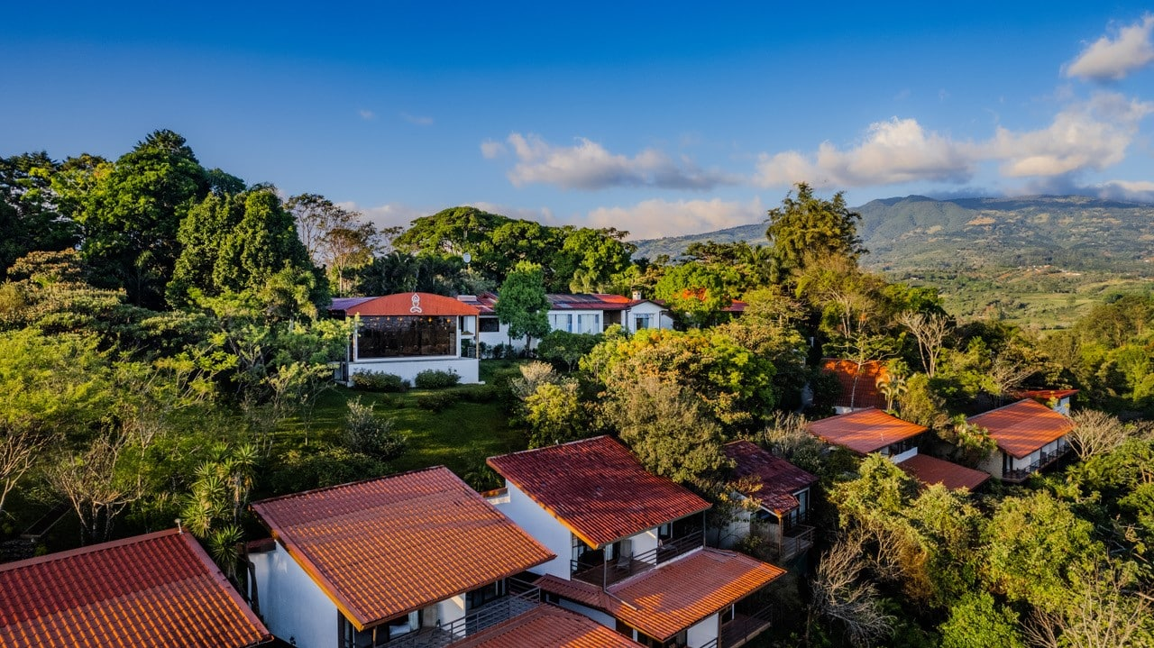

**Physical Address for Pura Vida in Costa Rica:**

Calle Puente Negro, 800 Mts SW of CENCINAI, Pavas, Carrizal, Alajuela, 020103 Costa Rica.

**Front Desk/Guest Services**:  Pura Vida staff are available to assist guests at the reception from 7am to 10pm each day, and staff are on-call around the clock in case of emergencies. Everyone in the office, the yoga teachers and the massage therapists all speak English.

**In-room Amenities** Liquid soap, shampoo and conditioner are provided in all rooms. Hair dryers are available at the front desk.

**Technology:** Free Wi-Fi is available throughout the property, although some areas may be less strong than others. You can expect to have 10 MB’s or less. Ethernet cables for a more reliable connection are available for guest computers near the reception area. Most cell/mobile phones work in Costa Rica, but we highly recommend that you contact your service provider before traveling, for assistance in selecting the appropriate package for you. Or, better yet, download WhatsApp to communicate with your friends and family while in Costa Rica free of charge  They must also download the program.   A phone is available for use in our guest lounge at the reception area.  Free calls to the US or Canada.

**OUR COVID** – 19 POLICY

Please review our FAQS page on our website for details about Covid-19 - <https://www.souliology.com/faqs>

**We suggest,** if you are flying to this retreat that you wear a mask while travelling on the plane to lower your risk of catching COVID.

**Again,** we recommend taking out travel insurance which includes trip cancellation insurance plus we recommend booking refundable flights to the retreat venue. While we are fully committed to hosting the retreat in person, we wish to acknowledge the uncertainties, and we believe it’s wise to safeguard your financial investment. (you may be able to avail of some cover through your credit card too; so please don’t forget to inquire).

If you require any further information, please do not hesitate to contact us at[**contact@souliology.com**](mailto:contact@souliology.com)**.** We are here to help.

**We are looking forward** to welcoming you on retreat with us to Pura Vida Retreat & Spa and thank you for choosing us to be part of your personal healing journey!

…..Nourishing Mind, Body and Soul